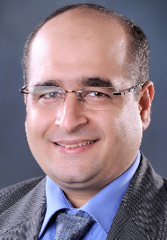
General Information about Portfolio Management Professional Credentials (PfMP) – Mohammed Mansoor – PgMP, PMP, RMP, SP, ITILV3 (PfMP Pilot participant)

Portfolio Management Professional (PfMP) is the latest certification offering from the PMI Stable. The PfMP pilot phase started on 20 December 2013 and ended on 28 February 2014 including more than twenty global participants. The results of the pilot phase are expected by the second quarter of 2014.
What is a portfolio?
A portfolio is a collection of programs, projects and/or operations managed as a group. The components of a portfolio may not necessarily be interdependent or even related, but they are managed together as a group to achieve strategic objectives.
What is portfolio management?
Portfolio management is the centralised management of one or more portfolios, which includes identifying, prioritizing, authorizing, managing, and controlling projects, programs and other related work to achieve specific strategic business objectives.
How does portfolio management differ from project management and program management?
Portfolio, program and project management are all aligned and driven by organisational strategies. However, each one contributes differently to the achievement of strategic goals.

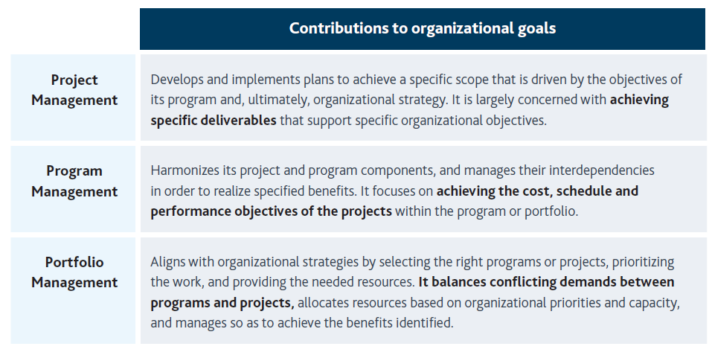
Why is portfolio management important?
Portfolio management supports the organisation’s strategic goals and, ultimately, its bottom line. Portfolio management is critical to organizing and prioritizing projects and programs and ensuring that the appropriate financial support is being allocated in support of those goals.
What is the role of the portfolio manager?
The Portfolio Manager is responsible for monitoring and managing assigned portfolios by:
- Establishing and guiding the selection, prioritization, balancing, and termination processes for portfolio components to ensure alignment with organisational strategy.
- Providing key stakeholders with timely assessment of portfolio and component performance.
- Assisting decision makers with the review, re-prioritization, and optimization of the portfolio.
- Ensuring timely and consistent communication to stakeholders on progress, impacts, and changes associated with management of the portfolio.
- Participating in program and project reviews to reflect senior level support, leadership, and involvement in important matters.

How does the PfMP credential differ from the Program Management Professional (PgMP)® credential?
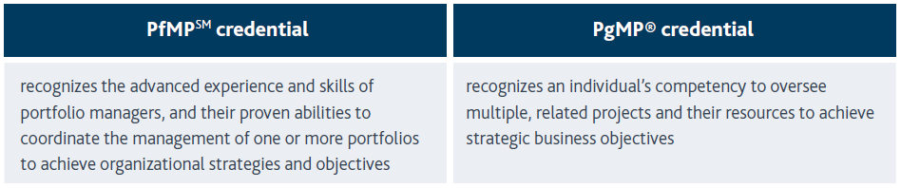
How does the PfMP credential differ from the Project Management Professional (PMP)® credential?
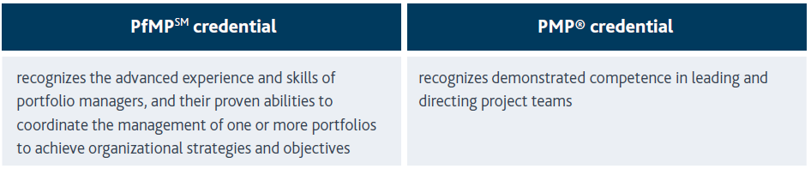
Who should apply for the PfMP credential?
- Practitioners who use portfolio management and are looking to validate their knowledge, skills, and experience.
- Project portfolio managers with four to seven years of portfolio management experience and a minimum of eight years of professional business experience

